**Lab 7**

**Aim: To implement and analyze OOP concepts of Inheritance**

**Bloom's Taxonomy Level: BT3 and BT4**

**Question 1:**

A class called **circle** is designed as shown in the following class diagram. It contains:

* Two private instance variables: radius (of the type double) and color (of the type String), with default value of 1.0 and "red", respectively.
* Three *overloaded* constructors - a *default* constructor with no argument, a constructor which takes a double argument for radius and a constructor which takes a double argument for radius and String argument for Color.
* In this exercise, a subclass called Cylinder is derived from the superclass Circle as shown in the class diagram
* use super() and super(radius) and inherits the variables and methods from the superclass Circle

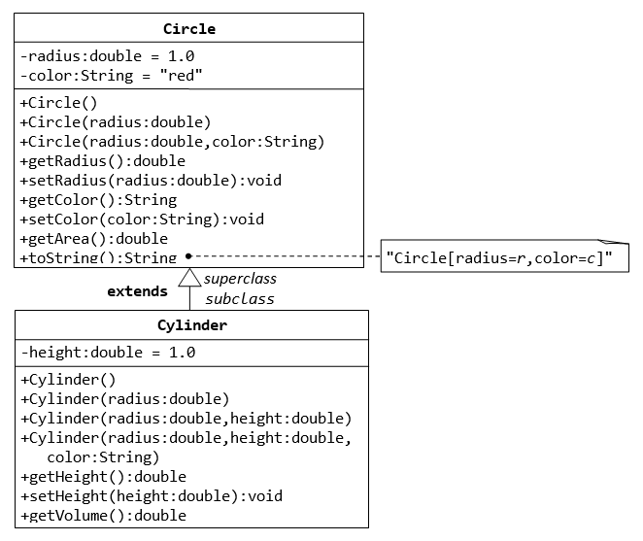

Write a test program (says TestCylinder) to test the Cylinder class created. Create three objects of Cylinder class namely c1,c2 and c3 as below and display height,radius, area and volume of all the objects

Cylinder c1 = new Cylinder();

Cylinder c2 = new Cylinder(10.0);

Cylinder c3 = new Cylinder(2.0, 10.0);

**Require Output:**

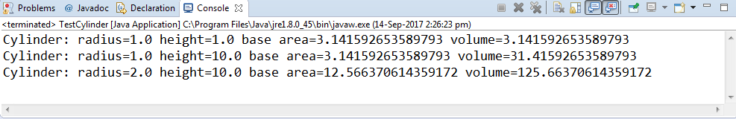

**Question 2:**

Write a Java Program to implement the following class diagram.

